**A Contribution to Nanotechnology Development Strategy**

The full potential of roadmapping as a strategic management tool at a regional level remains to be fully appreciated, especially when it comes to supporting regional policies directed at fostering the development of selected technologies

This article presents integrating roadmapping, and describes its application in a project entitled "Technological foresight 'NT FOR Podlaskie 2020' Regional strategy of nanotechnology development".

The intention of the research carried out in the project was to define strategic directions for the development of Podlaskie region based on the postulate of a leap in productivity growth, resulting from mastering and implementing innovative production, processing and service processes utilizing the achievements of nanotechnology, while protecting the environmental values of the region.

The research intended to define strategic directions for the development of Podlaskie region utilizing the achievements of nanotechnology

This approach made it possible to design regional strategies by identifying nanotechnologies that offer high socioeconomic benefits in the long run.

**SECTION II.**

## **Background Literature**

Based on a search in databases of scientific publications roadmapping methods in the context of foresight research and region were identified.

Fig. 1 presents an ideal way technology can be related to product development, R&D, available resources, and market opportunities.

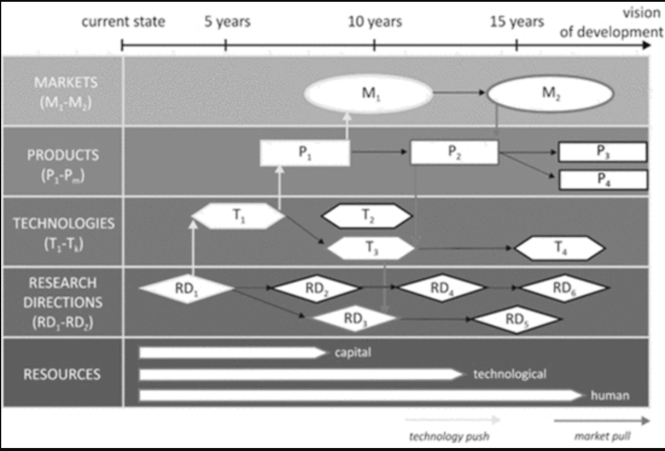

A correct document presents several layers of financial resources. A correctly executed document presents several layers of different levels of detail, which provides recommendations for decisions concerning investments and the allocation of financial resources.

The article's authors agree that roadmapping helps technologies, products, applications, markets, and society in national challenges. The article's authors agree that modularity for integrated roadmapping helps technologies, products, applications, markets, and society overreach national challenges.

A characteristic element of roadmapping is the time factor. The author presented the formation of megatrends and subtrends in five time zones, which directly inspired the presentation of time zones in roadmaps for nanotechnology development.

**SECTION III.**

## **Foresight in Shaping the Technological Development Strategy of a Region**

(The high complexity of factors that determine regional development requires a systematic method of anticipation and vision building)

In the long term, a foresight methodology is an effective tool for socioeconomic benefits. point at In this context, foresight methodology offers its potential as an effective tool to point at the strategic areas that offer high socioeconomic benefits in the longer run

A combination of regional foresight with technology roadmapping would prove on both scientific and policy levels. The authors intended to combine regional foresight with technology foresight and technology roadmapping. It was assumed that it would prove valuable on both scientific and policy levels.

**SECTION IV.**

## **"NT FOR Podlaskie 2020": Rationale and Methodology**

### Rationale, Scope, and Aims of the Project

-grant from the EU Operational Program 2007–2013.

-try to to promote nanotechnology where traditional industries cannot accelerate the development. Attempts to promote nanotechnology in a situation where traditional industries cannot accelerate the region's development.

- more than 160 experts were involved in the project.

-expert panels were divided into methodological and research areas panels. The expert panels were divided into methodological panels (STEEPVL, SWOT, TMKTP and SRP) and panels of research areas(NT in economy (RF1); NT research for development (RF2); Key factors of NT development (RF3)).

SSP panel was to identify the conditions for the development of nanotechnology in the area

TMKTP or Technology Mapping and Key Technologies Panel: This panel allowed separating the catalog of nanotechnologies

SRP or Scenarios and Roadmapping Panel: panel was to develop scenarios for the development of nanotechnology in the area

(The research tasks were to have interaction between six expert panels: SSP, TMKTP, SRP, RF1, RF2, and RF3. The results were integrated by the Key Research Team (KRT) also acting as a platform of interaction and knowledge transfer between the panels)

### B.Research Methodology Implemented in the Project

To include roadmapping in the research process, we need to demonstrate the interrelationship between resources, R&D, and market

To include roadmapping in the research process, we need to demonstrate the interrelationship between resources (human, financial, and material), the R&D, and the potential market of nanotechnology

Used methods are shown in fig. 2. As shown in fig. 2, the used methods were

1. Bibliometric analysis.
2. STEEPVL analysis.
3. SWOT analysis.
4. Technology mapping.
5. Key technology.
6. Scenarios.
7. Roadmapping.
8. Brainstorming.
9. Moderated discussions.

**SECTION V.**

## **Methodological Framework for Roadmap Development**

## A. Technology Mapping

technology prioritization, and the technology mapping method was the subject of work of the TMKTP panel, to identify if NT would make sustainable social and economic development in the area.

The stages of technology mapping were: literature studies, technology relation matrix, using tools for collecting information, selecting data, analyzing the links, and showing them in graphs.

stages of technology mapping:

-literature studies result in the diagnosis of the current state of technologies and the idea of technology mapping

- implementation of technology sheets and the technology relation matrix

-Collecting information from experts by using the created tools

- categorization and selection of the collected data

-analyzing the links among all the key technologies

- In the final phase, the relations among priority technologies were analyzed graphically.

### B. Roadmap Development Methodology

(The analytical work of KRT on the implementation of the roadmapping methodology leading experts in the field of priority technologies hired from the TMKTP panel, shaping the development of nanotechnology in the area.)

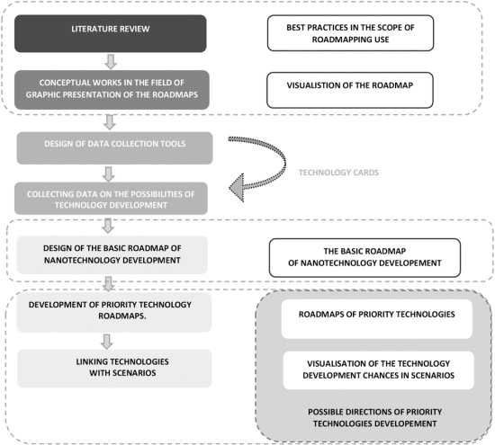

tasks of roadmapping research were: the possibility of using technology management, graphic presentation, Construction of a questionnaire, Collecting data, Designing a basic roadmap, Developing the priority roadmaps and Linking them with scenarios.7 process of roadmapping research tasks:

-possibility of using technology management in the region

-graphic presentation of roadmaps

- Construction of a questionnaire on the development of priority technologies

- Collecting data on the possibilities of technology development

-Designing a basic roadmap.

-Developing priority technology roadmaps.

-Linking technologies with scenarios.

(methodology was backed up by Magruk's concept)

(The task of the expert panel of the scenario and technology roadmaps was to integrate the work of the remaining five expert panels in the project. These panels included three panels of research areas (RF1, RF2, and RF3) and three methodological panels(STEEPVL and SWOT-Technology mapping and key technologies-Scenario building and technology roadmapping)

### C. Visualization of Technology Development Roadmaps

roadmap aspects are: R&D sector, identified Products, production, and resources. development of the technology roadmap aspects:

- The needs of the industrial and R&D sector

- identified Products, services, and undertakings

-production of new products and services allowance

-resources that allow the implementation of the desired vision

Layers of the roadmap are: Resources, R&D, creating given technology, potential areas, and technology. experts evaluated the five layers of the roadmap:

-Resources

-R&D

-Entities creating a given technology.

-Areas of potential applications.

- technology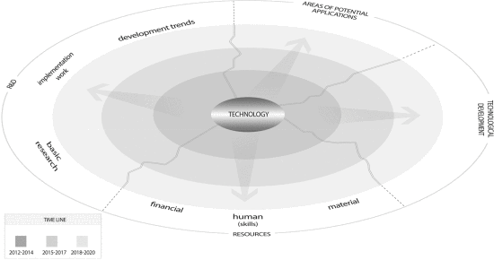

The technology roadmap was based on human, financial, and material resources, placed in the lower layer of the figure. given technologies are stimulated by the R&D. In the upper part of the figure

**SECTION VI.**

## **Results**

areas are presented. They form the background for the "market" layer. In the right part of the figure, the general development of given nanotechnology was presented.)

### Key Nanotechnologies

The individual levels of technology development are divided into three phases:

Research and development (TRL1–TRL3).

Testing and demonstration (TRL4–TRL7).

Realization and implementation (TRL8–TRL10)

All key technologies had an average rating of between levels of maturity 5 and 7

The final priority technologies were: NT for cutting tools, dental filling composite, medical equipment, biomedical applications, dressings, plastics processing, and Nano-structuring technologies. The final group of priority technologies was formed by these 7 technologies:

- Nanotechnologies for cutting tools and wood processing

- Composite materials-permanent dental fillings

- Nanomaterials and nanocoatings in medical equipment

- Topcoat nanotechnologies for biomedical applications

- Nanotechnologies related to special textiles such as dressings

- Nanopowder technologies for the use in plastics processing, paint, and varnish compositions

- Nano-structuring technologies for metals and light alloys

(Each of the priority technologies was characterized by a selected expert (see Table I).

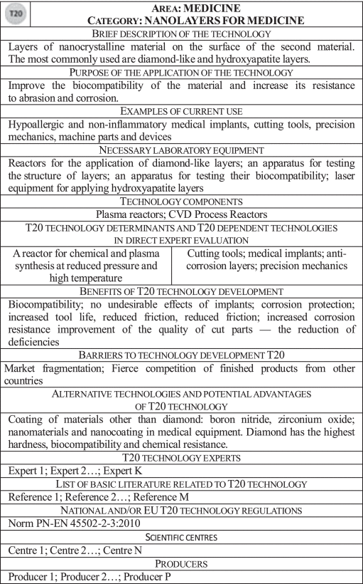)

### B. Technology Sheets

Priority Technology Sheets are assessments of technological readiness, attractiveness of the technology, and relationship between the technologies

The results of the work presented in this article are complemented by the following Priority Technology Sheets.

-The average of expert assessments of the level of technological readiness

-The average level of attractiveness of the technology and the feasibility of the technology

-The relationship between the technologies is shown on the map of key technology relationships.

The research centers and producers associated with each technology were also identified.

### C. Scenarios for Nanotechnology Development

four scenarios consisting of 65 factors were formulated. Also, R&D potential and collaboration in academia, business, and administration are NT driving forces.

scenarios consisted of 65 social, technological, economic, environmental, political, legal, and value-related factors

Two driving forces of nanotechnology development were R&D potential for NT and the effectiveness of collaboration in academia, business, and administration.

According to Table II, four scenarios of nanotechnology development in the region were formulated.

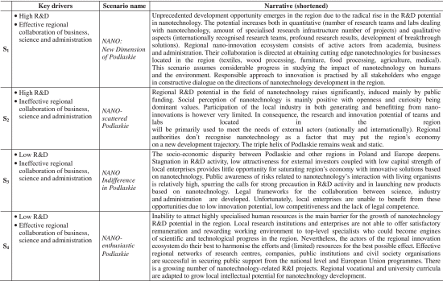

Fig. 5, shows the assessment of development chances with the influence of one technology on the others. The research team judged the chances of each technology's development in a particular scenario. In Fig. 5, the expert assessment of development chances is illustrated together with the influence of one technology on the others.

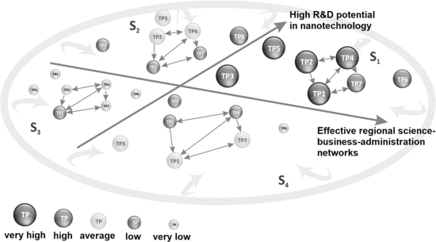

### D. Roadmaps

The financial outlay has been estimated at 1.5 to 15 million Dollars. And they have a plan to reduce the production costs. Medical equipment is an example of a Technology roadmap in this article. The necessary increase in financial outlays in all three time-perspectives has been estimated by the expert at an average level, USD 1.5–15 million.

Implementation works will evolve over the period 2015–2017 to reduce the costs of production

An example of Technology roadmap for nanomaterials and nanocoatings in medical equipment has shown in this fig.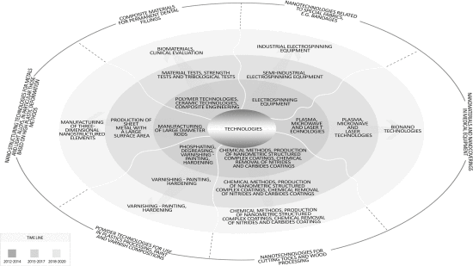

### E. Strategy of Nanotechnology Development

The basic elements of the strategy and their mutual relations are graphically presented using a nanotechnology development map

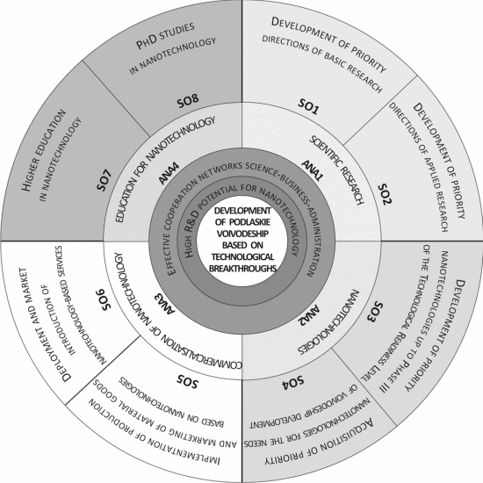

The map is divided into four parts. Research, nanotechnology, commercialization, and education. They point to two factors. high R&D potential and networks.

The map is based on a circle, the plane of which is divided into four parts of nanotechnology activity: research (ANA1), nanotechnology (ANA2), commercialization of nanotechnology (ANA3), and education for nanotechnology (ANA4).

(The following circles point to two critical success factors for NT: a high R&D potential for NT and effective regional networks like science, business, and administration)

**SECTION VII.**

## **Discussion**

The authors of this article demonstrated clear links between priority technologies and strategy development for the region

They point to two factors for the development of nanotechnologies. high R&D potential and networks. And they can investment in innovation in universities, local government, and civil society.

the greatest chances for the development of nanotechnologies are in the conditions of high R&D potential for nanotechnologies and effective regional networks for business, science, and administration

government should focus on activities aimed at building the R&D potential for nanotechnologies as well as building effective networks of cooperation of business, science, and administration

This concept aims to highlight the function of investment in innovation in high technology sectors like universities, local government, and civil society.

Conducting a survey among the regional stakeholders showed their positive responses towards the possibility, effectiveness, and possibility of the nanotechnology development strategy

**SECTION VIII.**

## **Conclusion**

It was revealed that innovative strategy formulation methodology combined regional foresight and technology foresight was an inspiration for academia. However, the recommendation to make nanotechnology development a regional priority never made it to the official strategic documents.